- There are 2 types of Hypervisor
  - 1. Type-1 Hypervisor
    - Here, Bottom layer is Hardware, then Hypervisor, then multiple Virtual Machines
    - There is no Host OS in this case. You can imagine as dual-boot as having Type-1 hypervisor.
  - 2. Type-2 Hypervisor
    - Here, bottom layer is Hardware, then Host OS, then Hypervisor then multiple VMs.
    - Ex: Oracle Virtualbox, you can install it on windows (for example) and lunch multiple virtual machines
  - 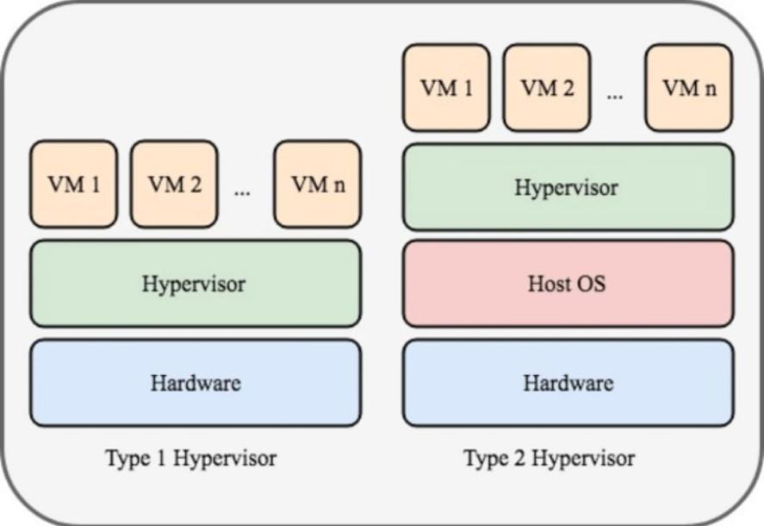
- OS consists of 2 things (in case of no container)
  - Kernel
    - It is the core part which talks to actual hardware.
  - User space
    - It is containing of the systemd, shell, libraries, applications (like node, java ..etc)
- When we hit node server.js the following steps are executed:
  - System call
  - Kernel
  - CPU / Memory / Disk

- Containers
- What happens when we run some application or execute some commands?
  - The kernel loads the binaries first.
  - Lets say you execute node server.js then Kernel will load the binaries; because Kernel doesn’t know anything but the binaries.
  - In normal system (having no containers), the application (node.js in our case) is installed at some directory, Kernel will load that.
  - So, all the thing that Kernel needs the binaries.
  - So, the idea is, why to install those dependencies/applications in our system? Just keep it in some other path and inform Kernel to use the binaries from that path.
    - This is the core idea of Containers.
- Containers
  - The containers only contains the application dependencies, and there is something called as Container Runtime in the VM (VM of host machine where the container will run), that’s tells Kernel to use the Binaries from that path instead of finding in its own System.
  - There is no Container Runtime during the running state of containers, its just there to set the isolation rule before starting the container.
  - Container Runtime doesn’t sit between Application and Kernel.
  - Each container has its own filesystem with its own binaries and dependencies (Node, Java, Maven, etc.).
  - When containers run, the kernel executes binaries from each container’s own filesystem view, because each process has a different filesystem namespace, they cannot see or interfere with each other’s dependencies.
    - namespace means PID, User etc etc.
    - 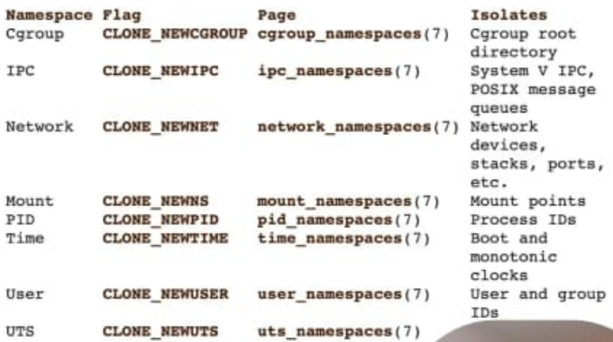
    - Means, the root user inside the container might be some non-root user in the system that is running the container.
    - Application inside the container thinks there is only one process having PID (assigned to itself) is running in the system, but there might be so many processes having different PID running in the systems.
  - 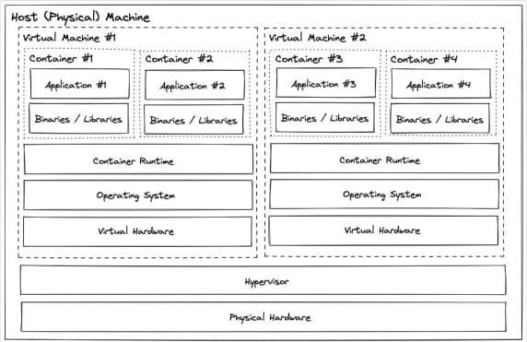
  - The container might be running in the Host only, or any of the VMs running on the Host.
  - The VMs are having their own Kernels (of course because they are having their Own OS and Kernel is a part of OS only)
    - And they are having their own set of Virtual Hardware that are being assigned to them (like Memory, CPU etc)
- What does it mean by Isolation? Every application present inside the container are running just like a different application (like Chrome, Firefox) right?
  - The containers are not having any dedicated Kernels, they share the host kernel.
  - Any 2 containers running doesn’t interfare each other, the have their own set of libraries or dependencies.
  - Kernel will use their versions of libraries and run them. So, there is no dependency collision or something like that.

- Layers in Container
  - A Docker image is made of Layers.
  - Layers are created line-by-line from the Dockerfile
  - Layers are read-only.
  - When a container runs, Docker adds one more extra writable layer on the top.
  - Example:
    - 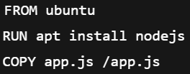 (Dockerfile)
    - This creates layers like
      - Ubuntu layer → base OS files
      - Node.js layer → Node installed
      - App layer → your code
      - Writable layer → created when container starts
  - Why layers exist ?
    - Speed → unchanged layers are reused
    - Less storage → same layers shared by many containers
    - Easy updates → change only the top layer
    - Example: 10 Node.js containers → all share same Node layer, Only app code layer is different
  - Writable layer
    - Containers cannot change image layers
    - Any file write goes to the top writable layer
    - When container is deleted → data is gone;
  - That’s why use volumes to store the data like DB data, logs, uploaded files etc

- Layers before & after runtime (IMPORTANT)
- First thing: Dockerfile can create only one type of Container (can have multiple containers, but all will be identical) if there is no variables are used inside the Dockerfile
  - 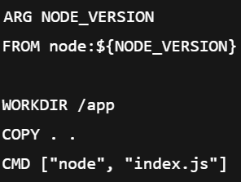
    - In this case, depending upon the NODE_VERSION variable different type of containers can be created (it is different)
  - 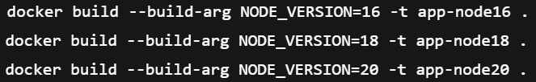
    - You can create different types of containers like this

- How the layers are created and how those are re-used (or shared) ?
  - Consider the below Dockerfile
    - 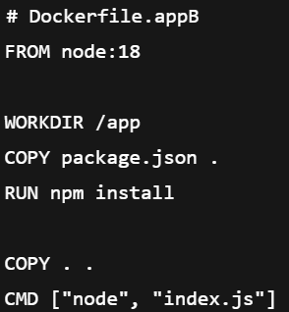
    - Here I the node version 18 is being used.
  - Now you build this docker file using docker build command, Docker will create all the layers.
  - When we run the docker using docker run command.
    - It’ll create layers from each line of this Dockerfile
    - Like Node-18 layer will be present in this case
    - And it’ll store a unique hash of each layer
  - After that, let’s say I executed docker run for this Dockerfile again or for some other Dockerfile that contains Node-18 image again
    - Now again Docker will scan that Dockerfile, and then see there is a layer already present that have Node-18 (checking the hash) and it’ll re-use that layer only, without creating another layer.
  - These all sharing and all are done by Docker (not Kernel)
  - After creating the layers, it’ll ask Kernel for the namespaces like PID, and all
  - Then Kernel will run this.

- Example of this Layer creation
  - Consider this Dockerfile again
    - 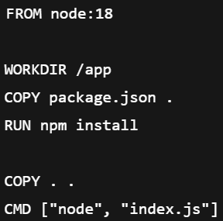
  - Now execute build command
  - Now Docker will creates a IMAGE layers (read-only) (layers are created by docker, not Kernel)
    - 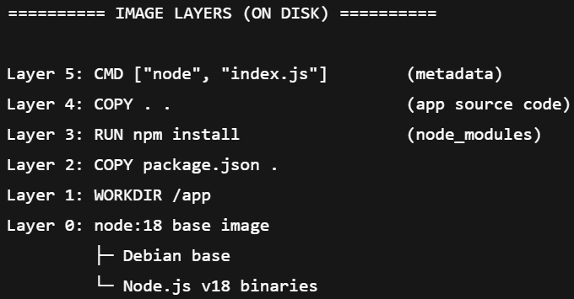
    - These layers are stored once, identified by hashes, read-only,
  - Now execute run command
    - 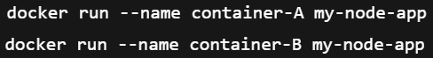
  - Now the layers in the runtime
    - 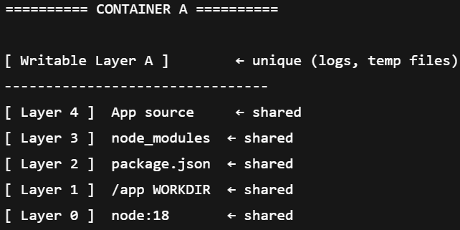
    - 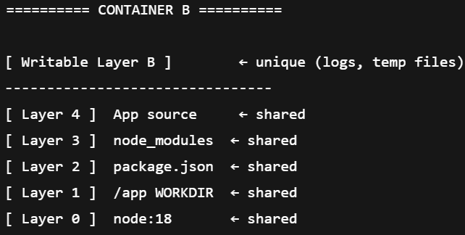
    - All the layers were present, so it is shared now
  - Even if the layers are shared among the containers, but the namespaces (PID, network etc etc) are different for all the containers. Also the writable-layer is unique for all containers.
- As container uses the same Kernel of its host, so the host should be Linux as well. Then How are we able to run containers in our Windows or Mac?
  - Docker desktop create a Linux VM underlying and docker containers run on top of it.
- Name spaces, control groups (cgroups), union filesystems //TODO

- You can run the containers from docker hub like below
- As the data is not persisted in the container, because after destroying the containers all the data will be lost, we can use 2 types of mount
  - Volume mount
    - Here one docker volume is created and mounted to the container
  - Bind mount
    - Here, one directory of the host machine is mounted to the container.
    - It is not recommended because its crossing the boundary of container.
- Consider the below command
  - docker run ---- create + start a container
  - --interactive ---- keeps STDIN open (you can type commands)
  - --tty ---- allocates a terminal (nice shell experience)
  - --rm ---- automatically deletes the container when you exit
  - --interactive --tty can be reduced to -it
- Every time you run the container, it’ll be having a different container ID
  - 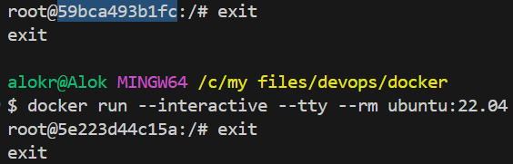
- See the below steps
  - I now ran one container without givine rm and giving one name
  - Then I installed iputils-ping to try to ping any server.
    - 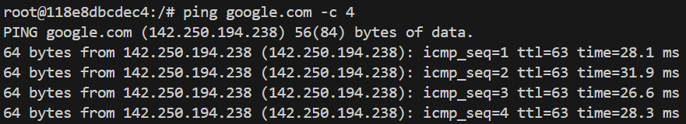
  - Then exited using exit command
  - Now the container will not be deleted after executing exit command because we didn’t give --rm flag during running the container.
  - Now, if you do docker ps -a it’ll show you the container; docker ps will not show because the container is stopped.
    - 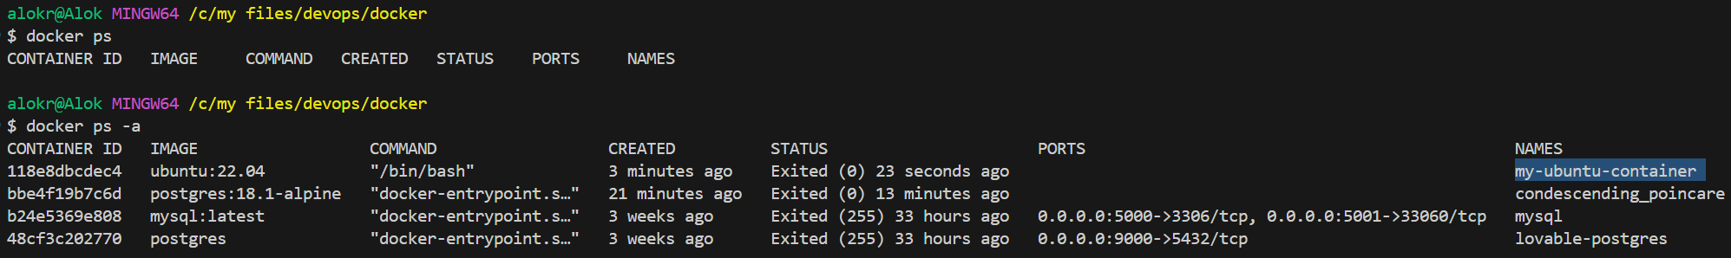
    - Even if this container is stopped, but its still having that read & write layers associated with it.
    - You can also execute: docker container ls or docker container ls -a
  - Now to start the container, execute the command docker start my-ubuntu-container
    - 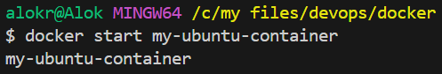
    - Now docker ps (without -a) will show this container
  - Now, to open the interactive shell execute the command docker attach my-ubuntu-container
    - 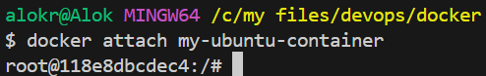
    - Now you don’t need to install iputils-ping again, because it is already there and you just started the previously created container which was stopped (not destroyed)
  - Here, we ran the container, then installed the iputils-ping package and did the things,
- But its not a good practice to run the container and then install the dependencies and all; its better to build the image that contains everything.
  - 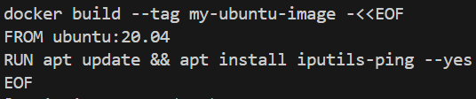
  - You can build the image like this. (EOF part is nothing but the contents that are written in Dockerfile)
- If you execute docker image ls now, you’ll be able to see the built image
  - 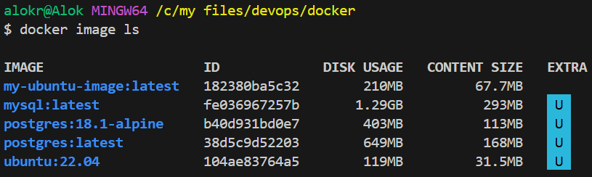
- Now if you run a container using this built image, you will not be needed to install iputils-ping image again, it’ll be there already
  - 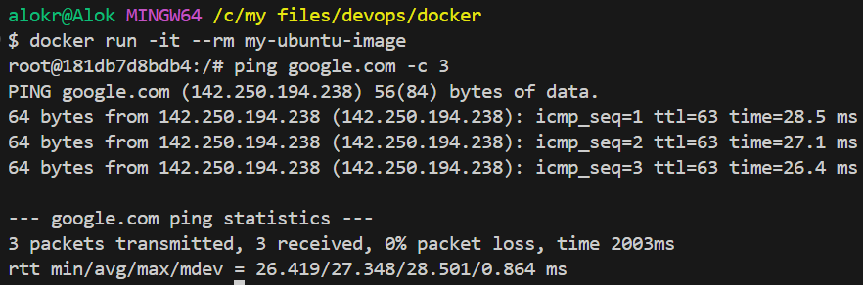

- Create a volume using the command docker volume create <volume name>
  - 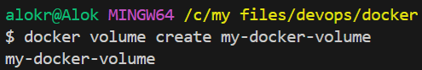
- Now run a container and mount that volume to a particular path of container.
  - The command will be: --mount source=<volume name>,destination=<path which to be mounted>
  - It’ll automatically create ont directory /my-data and now it is mounted to the volume that I created.
  - 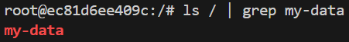
- I just created one file inside that directory /my-data
  - 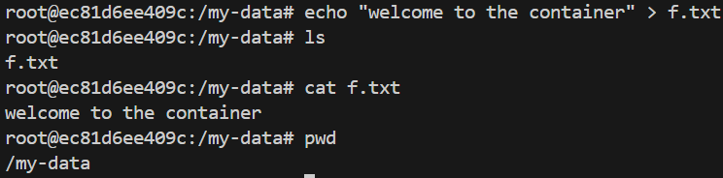
- Now exit, so that the container will be deleted (--rm was used while creating the container)
- Now, I created one more container, and now gave the mount destination path as “/some-dir”
  - 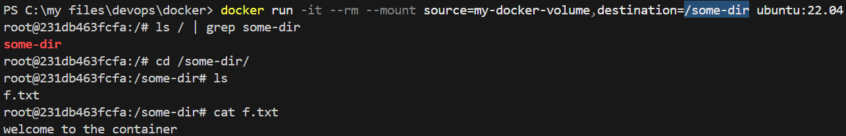
  - Now we can see the file is present in that “/some-dir” directory.
- I created one directory “my-data” in my pwd in my system (not in container)
  - 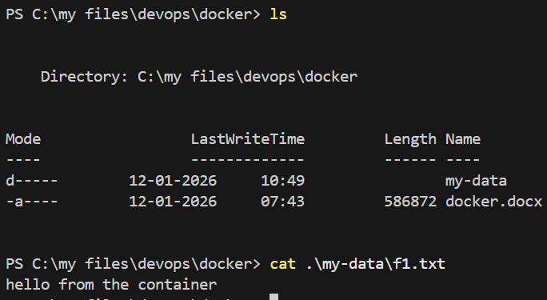
- Now I’ll bind this directory (bind mount) to a container
  - The command will be: --mount type=bind,source=<source dir path>,destination=<dir path inside container>
  - If you create something inside that “my-data” directory inside the container, then the same file will also be there inside the system’s directory.
- There is another way of mounting voluemes or binding the directory to the container, that is -v flag
    - If the volume is there then it’ll bind that; otherwise it’ll create one and bind that.

- Writing Dockerfile
- The following instructions are supported in Dockerfile
  - ADD Add local or remote files and directories.
  - ARG Use build-time variables.
  - CMD Specify default commands (after building container).
  - COPY Copy files and directories.
  - ENTRYPOINT Specify default executable.
  - ENV Set environment variables.
  - EXPOSE Describe which ports your application is listening on.
  - FROM Create a new build stage from a base image.
  - HEALTHCHECK Check a container's health on startup.
  - LABEL Add metadata to an image.
  - MAINTAINER Specify the author of an image.
  - ONBUILD Specify instructions for when the image is used in a build.
  - RUN Execute build commands (during building container).
  - SHELL Set the default shell of an image.
  - STOPSIGNAL Specify the system call signal for exiting a container.
  - USER Set user and group ID.
  - VOLUME Create volume mounts.
  - WORKDIR Change working directory.
- We can write some simple command like below inside the Dockerfile
  - 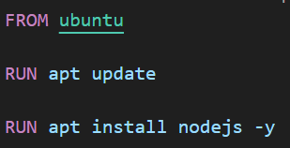
    - As each line will be created as a layer, we should avoid creating multiple layers. So, instead of writing like above, write like the below
  - 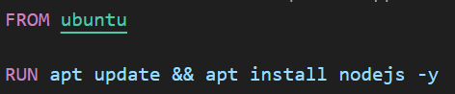

- Below are the stages of Dockerfile from non-optimized to optimized (for nodejs application)
- In the below case
  - 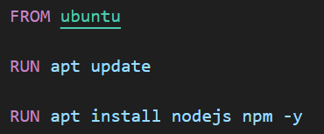
  - Writing RUN in different lines creates 2 different layers; we should minimize the number of layers to better to write in a single line.
- Stage-1 (building image tht runs nodejs applicatoin):
  - 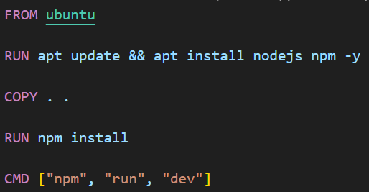
  - 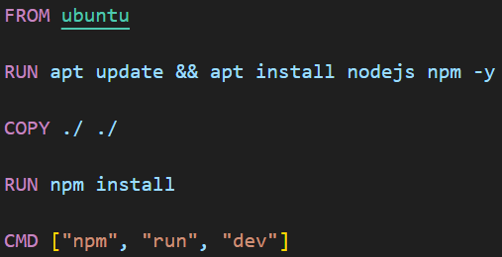
  - Both are same; . is same as ./ in this COPY command.
- docker build -t api-node:0 . is used to create a image giving a tag
  - That dot . at the end means use the default docker file which is Dockerfile
  - Otherwise you can give the dockerfile name
  - -t image-name:tag
  - 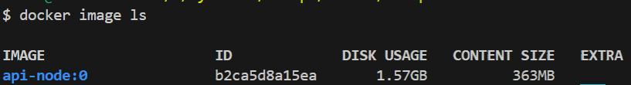
  - If you see here, the image is of 1.5 gb which is terrible.
- Stage-2 : used node container image instead of ubuntu
  - 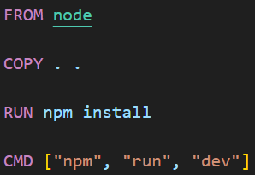
  - 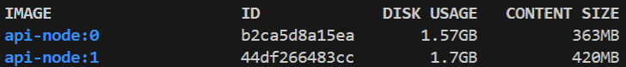
  - Now it is also huge; because node means it’ll find the latest node image and build using that.
- Stage-3 : used alpine version of node instead of default (latest)
  - 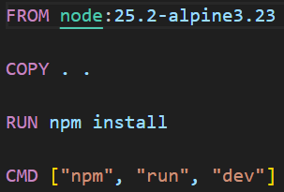
  - 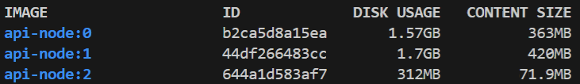
  - Now it is reduced to 312mb
- Stage-3 : till now we didn’t use the caching due to which build time was very high
  - 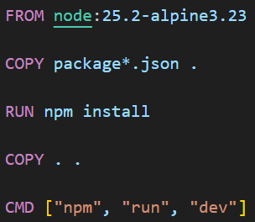
  - You might be thinking, this is same only; anyways all the files are being copied as we have written COPY . . after running npm install command.
  - Dockerfile instructions are executed top to bottom
  - Each instruction creates a new immutable layer
  - Layers are linear and dependent on previous layers
  - During build, Docker checks cache for each layer
  - Cache validation is based on:
    - Instruction content
    - Parent layer hash
    - Files involved (for COPY / ADD)
  - If everything matches → cache hit
  - If anything differs → cache miss
  - On a cache miss:
    - That layer is rebuilt
    - All layers after it are invalidated and rebuilt.
  - On doing this:
    - 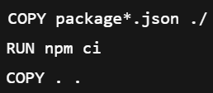
    - npm ci runs only when package*.json changes.
    - Source code changes do not invalidate dependency cache
  - Using only:
    - 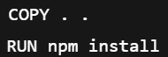
    - Any file change → cache invalidation
    - npm install runs every build
  - 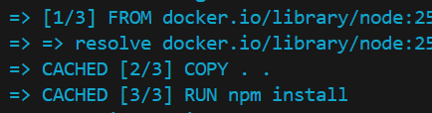
  - Now you can see it is cached so no need to build again.

- Stage-4 : you should give WORKDIR ,
  - by default when you write COPY . . it copies to the default work directory.
  - 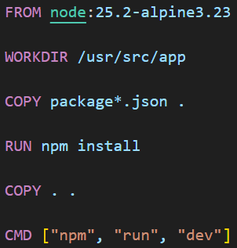
- Stage-4 : maintain .dockerignore file to ignore the files
  - 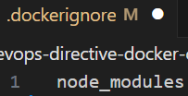
- Stage-5 : as it is a production container, we can run node index.js directly.
  - 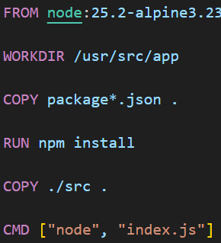
  - 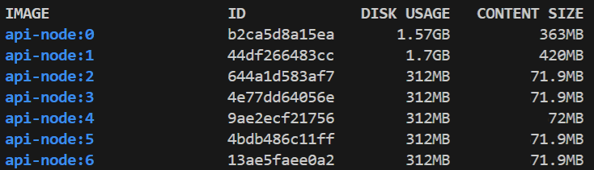
- Till now we are optimizing w.r.t. build time and image size; now we’ll optimize w.r.t. security.
- Stage-6 : execute the things as a non-root user.
  - In the node container image, there is a existing user named as node
  - 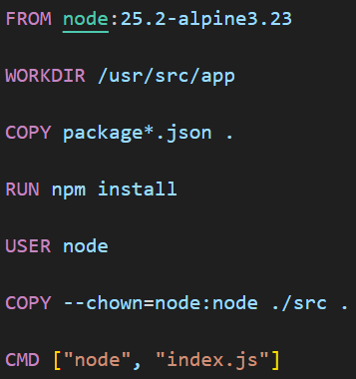
  - USER command just switch to that user; it doesn’t create a new user.
  - I made sure that those files should be owned by the user node
- Stage-7 : setting the environment
  - Mostly node application like react, express, next …etc uses NODE_ENV.
  - --only=production is npm’s flag; if --only is not specified then npm checks the NODE_ENV otherwise it’ll take the value from that --only flag only.
  - 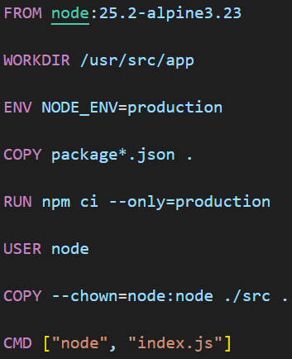

  - So, these below 2 are basically same only
    - 
    - 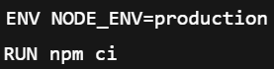
  - Now due to production environment the dev-dependencies were not installed so image size got reduced.
    - 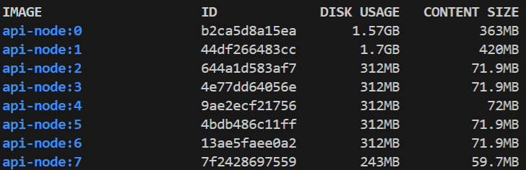
- Stage-8 : give EXPOSE port
  - EXPOSE doesn’t actually expose any port, it just add metadata just like the documentation.
  - 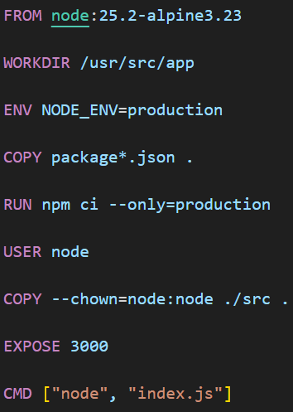

- Stage-9 : caching using DOCKER_BUILDKIT
  - In case of legacy build, if the cache is invalidated then it’ll be build again.
  - Take the below code:
    - 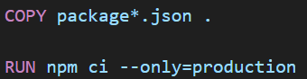
  - If the package.json is changed then it’ll download all the dependencies again.
  - Lets say we have added one more dependency in package.json, it should download that new one only and because remaining are same, it should take those from cache only.
  - But, legacy build was not working on this. It will re-download all those dependencies again from the beginning.
  - So, DOCKER_BUILDKIT solves this problem, it’ll only download the new one and the remaining will be taken from the cache.
  - Legacy:
    - Build 1: npm downloads everything
    - Build 2: npm download everything again
  - Buildkit:
    - Build 1: npm downloads everything
    - Build 2: npm downloads ONLY Changed Dependencies.
  - 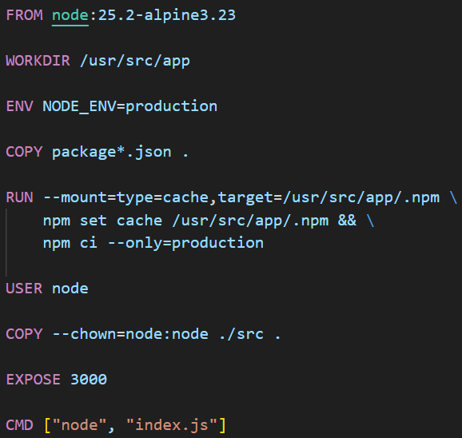
  - In case of Buildkit, the cache is outside of the image layers. Image layers cache are not persistent.
  - --mount=type=cache,target=/usr/src/app/.npm : create a persistent cache location
  - npm set cache /usr/src/app/.npm : points npm to that cache
  - npm ci : download only what missed in cache
  - You need to write DOCKER_BUILDKIT=1 in the command
    - DOCKER_BUILDKIT=1 docker build -t api-node:9 .

- Below are the stages of Dockerfile from non-optimized to optimized (for golang application)
- Stage 1 : base config using golang latest cont
  - 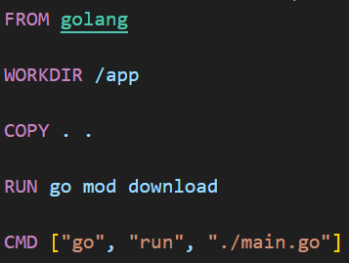
- Stage 2 : alpine version of the golang image
  - 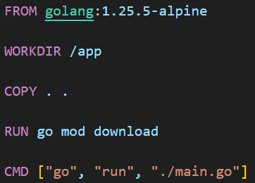
- Stage 3 :
  - In stage 2 we were using go compiler (go run ./main.go) which is slower & container requires go compiler inside it.
  - Its better to create binary executable file and run that directly.
  - 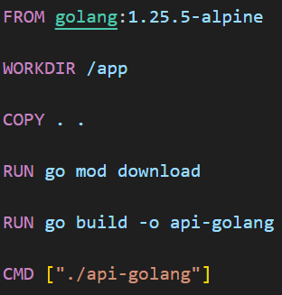
  - It means whenever we are starting our container, we don’t need to build the code again, it is already built; just run the binary executable file.
  - 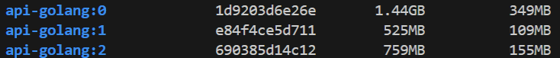
  - It is not possible for nodejs application because golang is a compiled language where as Node.js is an interpreted language.
  - We need to run node index.js in nodejs application, but in golang we can directly execute ./api-golang which is a compiled binary file.
- Stage 4 : optimize the COPY of files
  - 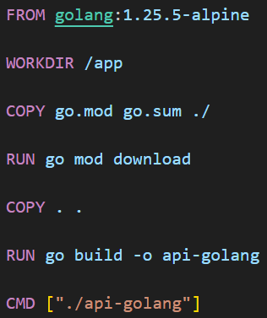
  - 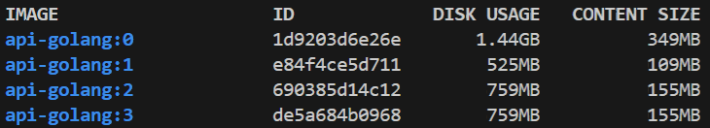
- Stage 5 : multi-stage build
  - scratch is a image that contains nothing.
  - We can use one image to build i.e. compile and generate the binary and will transfer this binary to another smaller image.
  - in case of go build -o api-golang it’ll generate the binary executable file but this file will be having dependency with the OS libraries.
  - So we’ll use -ldflags and -tags to create a fully static Go binary file.
  - 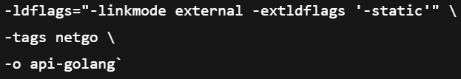
    - -linkmode external ==== Forces use of external linker
    - -extldflags '-static' ==== Links everything statically
    - -tags netgo ==== dns handled by go (netgo), not libc
  - 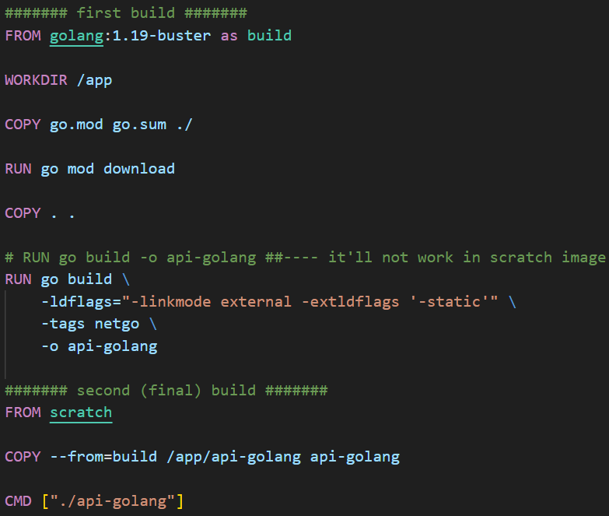
  - 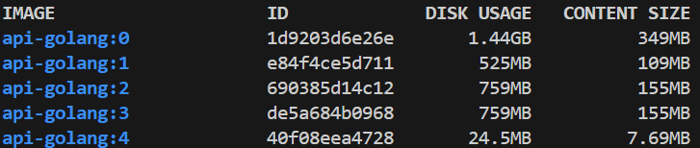
  - If you see now, this container’s size is just 24 MB

- Stage 5 : DOCKER_BUILDKIT caching, ENV variable & use EXPOSE
  - 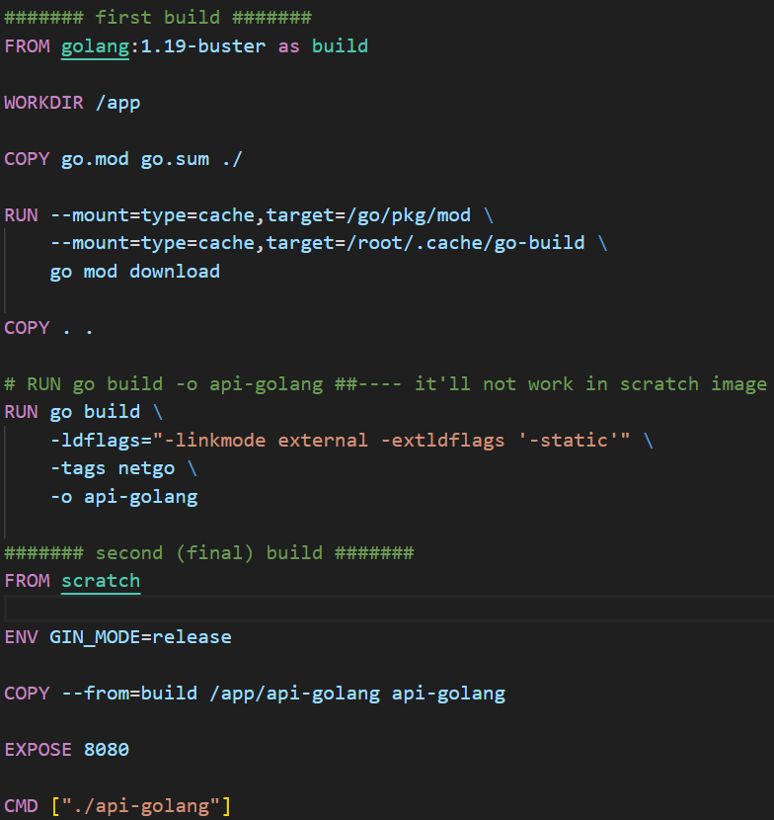
  - You can cache as many paths as you want.

- Stage 6 : use non-root user for all these
  - 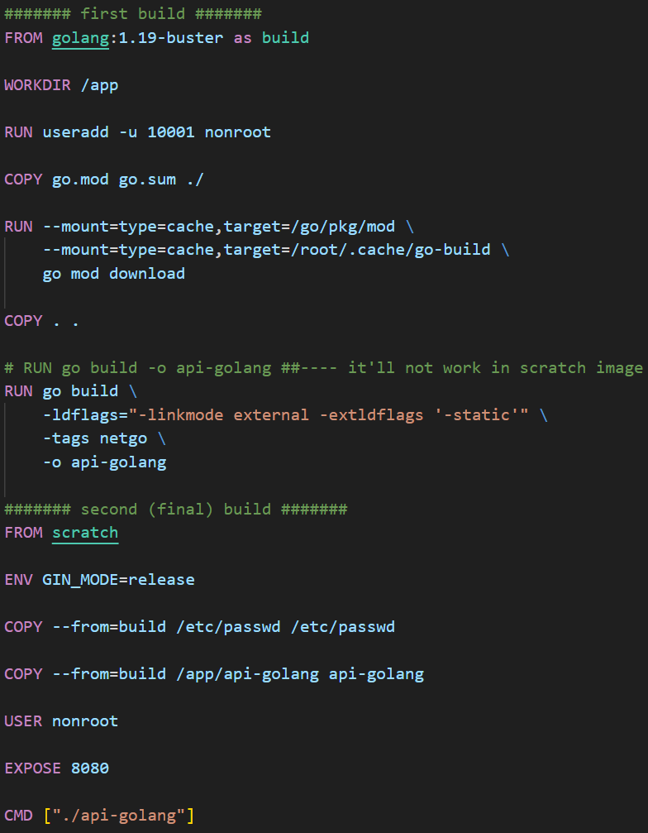
  - Create one user using RUN useradd command and copy the /etc/passwd file from

- Container Registries ///// TODO
- F

Running Containers
- docker run options
- docker run [OPTIONS] IMAGE [COMMANDS] [ARGS…]
  - -d : detached, it’ll not open the container after running
  - --entrypoint : to write a bash command which will be executed after building the container.
    - docker run --entrypoint echo ubuntu hello
    - COMMANDS section exists only if ENTRYPOINT is not supplying the executable.
    - Here, --entrypoint accept a value which is executable (like sh, echo ..etc)
    - So, --entrypoint echo === this is the [OPTIONS]
    - Then whatever I give without having - or -- will be treated as IMAGE.
    - After that, everything will be the ARGS for that echo command.
  - --env, -e, --env-file : set env variables during run-time
    - docker run --env MY_ENV=hello ubuntu printenv
  - --init :
  - --interactive, -l, --tty, -t : interactive shell, tty (-it shorthand)
  - --mount, --volume, -v : to mount docker volume or host’s directory
  - --network, --net : create a docker network
    - Docker network is kind of a virtual switch

- F
- F

- ENTRYPOINT
  - ENTRYPOINT[“node”, “server.js”]
    - You can write this inside the Dockerfile which is the entry point of the container.
  - ENTRYPOINT: defines the main executables
  - CMD : provides the default arguments
  - In case of CMD, it is easily replacable
    - 
    - 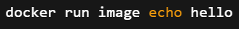
    - Now echo hello will be executed instead of node server.js
  - In case of ENTRYPOINT, only using --entrypoint can replace this
  - ENTRYPOINT + CMD
    - 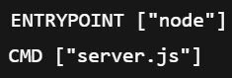
    - Default run: 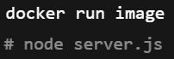
    - Override CMD: 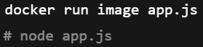
    - Override ENTRYPOINT: 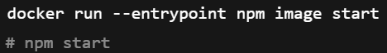

- Docker Network
- Every container gets their own private IP only applicable inside the Docker network.
- Lets say one docker network is there Network-A; and 3 containers are here in that network C1, C2, C3 (name of these containers)
  - Here, all these containers i.e. C1, C2, C3 can access each other as they are present inside the same Docker network Network-A.
  - Here they’ll access each other using the container names and Docker provides a DNS (one per each network) and resolve those container names to the respective IPs assigned to those containers.
- When you do docker inspect container-name, you’ll get one block with the key “networks” inside which you’ll find the IP assigned to the container, these IPs are only accessible within that Docker network, it has nothing to do with the outside world of that Docker network.
- One container can be present in more than one docker networks.
- Lets say Network-A container C1, C2 and Network-B contains C1, C3
  - Here, C1 can access C2, C3 because it is present in both the networks.
  - But C2 can only access C1 & C3 can only access C1; C2 and C3 cannot access each other.
- Consider the below example to know how Docker DNS work for a container present in multiple networks
  - 2 networks are there: A, B
  - A => C1, C2 ; B => C1, C3
  - Network A uses subnet 172.18.0.0/16
  - Network B uses subnet 172.19.0.0/16
  - Inside C1, Docker creates two network interfaces (lets say eth0, eth1)
  - One interface (eth0) is connected to network A and gets IP 172.18.0.1
  - Another interface (eth1) is connected to network B and gets IP 172.19.0.1
  - Inside C2, there is only one interface
  - That interface belongs to network A and has IP 172.18.0.2
  - Inside C3, there is only one interface
  - That interface belongs to network B and has IP 172.19.0.2
  - When C1 tries to access C2, DNS resolves C2 to 172.18.0.2
  - The routing table in C1 sends traffic for 172.18.0.0/16 via the network-A interface (eth0 in our case)
  - When C1 tries to access C3, DNS resolves C3 to 172.19.0.2
  - The routing table in C1 sends traffic for 172.19.0.0/16 via the network-B interface
  - C2 cannot access C3 because they do not share a common network
  - C3 cannot access C2 for the same reason
  - Docker DNS resolves container names per network only
  - Traffic always flows through the interface that matches the destination subnet

- To run database in a custom docker network:
- To configure (build + run) its better to use docker-compose.yml file
- 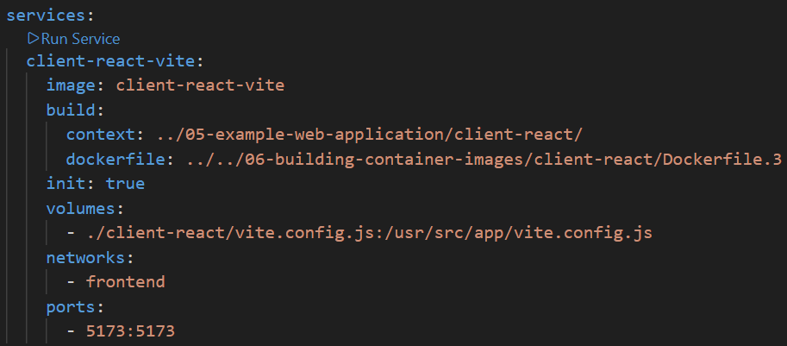
  - client-react-vite : here it is the service name; by default the container name will also be same as this.
  - build : here 2 things are there context & dockerfile
    - context : what file docker allowed to see
    - dockerfile : path of Dockerfile relative to context

- F

